Ideation Phase
Define the Problem Statements

Date | 25 September 2026
Team ID | SWTID-2026-7212
Project Name | AI Study Buddy
Maximum Marks | 2 Marks

Customer Problem Statement:
Students often struggle to manage large amounts of study material from different sources within limited preparation time. They spend a lot of time creating notes, summaries, revision questions, and study schedules manually. They also lack a single platform to organize their materials and track their learning. AI StudyBuddy addresses these problems by providing AI-powered summaries, flashcards, quizzes, personalized study plans, and centralized study resources in one platform.
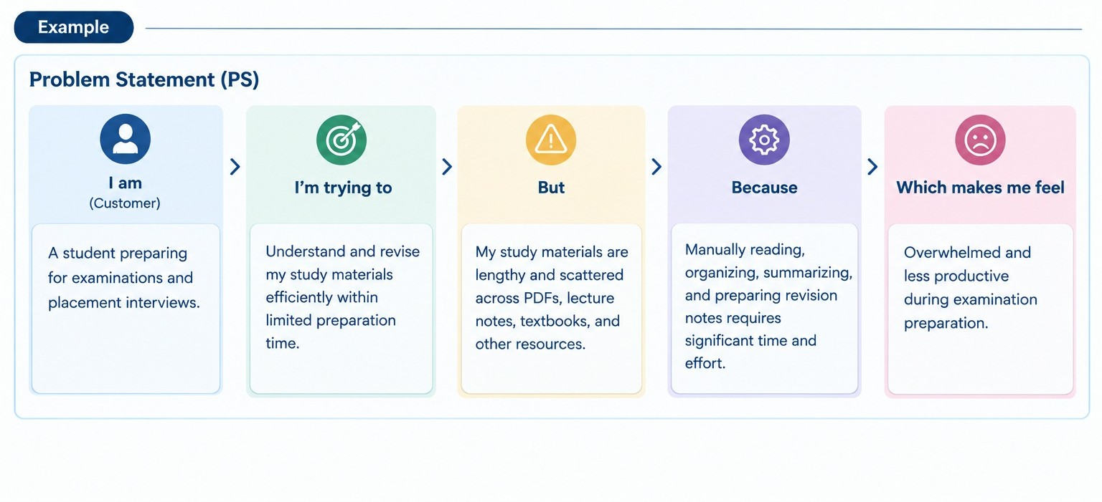
Problem Statement 2:

